Bryce Poeppel

Assignment 3

CSCI 44800

Data Acquisition:

Data was acquired through use of an extremely complicated rig. The required materials are any phone camera, a black T-shirt, a consistent unimpeded light source and a can of BBQ Pringles, the new sweet and tangy BBQ works best. In order to assemble the rig a the black T-shirt was laid upon the floor directly below the light in my room then the can of sweet and tangy BBQ Pringles was placed such axis of the Pringles can was about half way up my forearm. The hand upon the Pringles can held the phone camera and then my second hand was placed such that it was roughly centered with the fingers pointing in one direction upon the black T-shirt. There was no constraint placed on the hand but once the experiment was run it became clear that one thing should have been constrained, the thumb. The thumb should be spread such that the tip is below the webbing of other fingers else it messes with calculations slightly.

Assumptions:

The assumption was that it would still be moderately easy to gather the data even in a rather unconstrained system, but this did end up moderately affecting the results. The assumption was that the fingers could be easily identified to function as 4 of the 5 required axes for measurement. The final axis was then decided to be the part of the palm slightly below where the webbing of the hand ends. The figure below depicts this visualization.

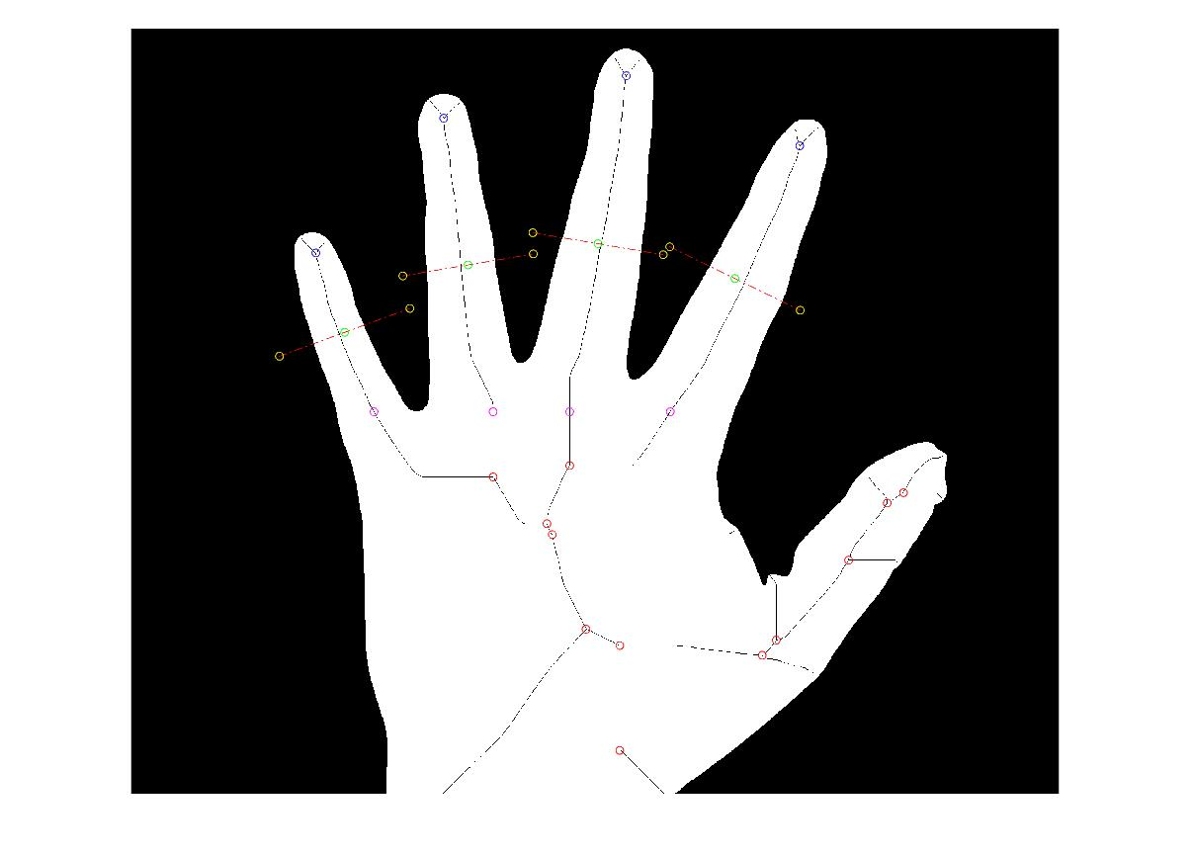Blue = finger tips

Yellow = axis end points

Magenta = palm axis

Red = unused

Green = midpoint of finger

The results:

The vectors that were generated:

|  |  |  |  |  |
| --- | --- | --- | --- | --- |
| 777 | 91 | 133 | 147 | 135 |
| 771 | 91 | 132 | 147 | 135 |
| 959 | 238 | 151 | 193 | 24 |
| 929 | 238 | 158 | 198 | 13 |
| 949 | 203 | 197 | 164 | 22 |
| 966 | 240 | 150 | 187 | 25 |
| 731 | 91 | 125 | 144 | 132 |

The first column is the palm then the next 4 are the fingers from left to right. These results show that the hand probably should have been more constrained. If you look at the visualization like the one posted above it is clear that the reason that the numbers in the middle vary so greatly is that in the middle 4 numbers the palm axis was lower. This is due to the way that the palm axis is calculated. It goes from the lowest fingertip and works its way down till it finds an uninterrupted segment that begins the palm. If the thumb is too high this algorithm reads the palm as being the part of the hand just below the lower part of the webbing of the thumb. Either having the thumb above the other finger webbings or below it still yields consistent results but one of the two must be chosen if this were to be implemented in a real system. The camera work probably could have been done better as well but overall this experiment showed some strong results as the positional placement of the thumb seemed to be the only major problem. If the camera work was steadier and the thumb was constrained in one of the two aforementioned ways I believe this algorithm would work quite well given the % differences has an approximate mean of 5% which could work as the threshold, though at 5% this system would probably lead to significant false positives. Given the extreme similarity of the first 2 results and the final results I constrained my thumb and reran the experiment 7 more times (this time we only have regular Pringles bummer).

The new data is:

|  |  |  |  |  |
| --- | --- | --- | --- | --- |
| 680 | 92 | 124 | 135 | 125 |
| 688 | 89 | 124 | 134 | 124 |
| 765 | 79 | 128 | 139 | 128 |
| 743 | 85 | 126 | 140 | 128 |
| 696 | 94 | 125 | 134 | 120 |
| 722 | 91 | 126 | 135 | 121 |
| 732 | 92 | 128 | 139 | 122 |

The new experimental data showed much more promising results. As can be seen the mean percent difference closed significantly give this relatively minor constraint. The only highly varied measurement was the palm measurement and that is likely just due to a weaker implementation.

ROC:

I used all 14 points, minus 1 to consider the reference, to do the ROC curve and this was the resulting curve.

Which is weird and I “think” I did something wrong about graphing it but here is the data that was used to graph it:

|  |  |  |  |  |  |  |  |  |
| --- | --- | --- | --- | --- | --- | --- | --- | --- |
| Threshold | TP | TN | Pred P | Pred N | FP | FN | FPR | TPR |
| 40% | 10 | 4 | 12 | 2 | 2 | 0 | 0.333333 | 1 |
| 30% | 10 | 4 | 11 | 3 | 1 | 0 | 0.2 | 1 |
| 15% | 10 | 4 | 9 | 5 | 1 | 1 | 0.2 | 0.909091 |
| 10% | 10 | 4 | 9 | 5 | 0 | 1 | 0 | 0.909091 |
| 5% | 10 | 4 | 7 | 7 | 0 | 3 | 0 | 0.769231 |
| 2% | 10 | 4 | 5 | 9 | 0 | 5 | 0 | 0.666667 |
| 1% | 10 | 4 | 3 | 11 | 0 | 7 | 0 | 0.588235 |
| 0.50% | 10 | 4 | 0 | 14 | 0 | 10 | 0 | 0.5 |